A Song of Tales Rules V 1.08 12/08/2020
Throughout time there have been tales, eternally retold. Wherever folk gather about the fireplace the best seat is always kept for the storyteller. Can you take your place and weave your tale? Can you capture your listeners and use their words to strengthen your own tale? Can you find your place in the Song of Tales?

Box Contents –
This rulebook.
8 Large sized Character cards.
8 Large Character meeples.
56 Small Character meeples (Envoys).
64 Tale cards including:
- 8 Beginning cards
- 8 Ending cards
- 48 Story cards
1 60 second Sand timer.
1 The Last Word marker.
1 Storyteller marker.

Overview –
Song of Tales is a game of collaborative but competitive storytelling. Players will take turns telling tales based on sets of Story cards they play during their turn. The more Story cards they can weave together into a tale, the more points they will score, but tales will be told under time pressure; the longer the tale, the higher the pressure. Time can be gained by allowing other players to temporarily take over the telling of the tale. Players fail when they run out of time, stop making sense or miss out the motifs of their tale. At the end of the game, the Story-Teller with the most points will win.

The rules –
Throughout these rules you’ll see summary box-outs:
That look like this.
They will contain the basic facts without explanation, so you can find them when you need to, during play.

Set-up –
Each player selects a large-scale Character card and finds the matching Beginning and Ending cards. For your first game use the “Starter” version of the Character card, the one with * next to its name.
Everyone should place their Beginning card in front of them on their left and their Ending card on their right, with enough space between them to allow story cards to be placed between them.
Next, find the “meeple” markers matching your character, there will be one large and seven small. Place one of the small ones and the large one on the zero of the box cover, they’ll track your score. During the game you’ll need to use your supply of markers to be allowed to activate certain abilities. From now on we’ll be calling the little meeple markers not on the scoring track Envoys.
Shuffle the Story cards and deal 3 to each player, stack the remainder face-down to form the Story Draw Deck. Everyone can pick up the cards dealt to them and look at them. Try to make sure that all the players can easily reach not only the Story Draw Deck, but also the areas between each other’s Beginning and Ending cards. Designate an area next to the Story Draw Deck to be its Discard pile. Note: If the Story Draw Deck ever runs out it will trigger the end of the game, the Discard pile is NOT shuffled and re-stacked.
The player with the best seat is the Story-Teller, all other players are Listeners. Don’t worry, everyone will get a go at being the Story-Teller eventually, until it’s your turn, you need to be ready in case the Story-Teller decides to Share The Telling with you. Hand the Story-Teller the Story-Teller marker, and hand the player on the Story-Teller’s right the Last Word marker.
For each player:
1 – Take a Character card, its Beginning and Ending card, and Envoys.
2 – Place their Beginning and Ending cards on the table.
3 – Place their large Envoy and a small one on the scoring track.

Once:
1 – Shuffle the Story cards and deal each player 3, stack the remainder into the Story Draw Deck.
2 – Choose a Story-Teller, hand them the Story-Teller marker and the player to their right the Last Word marker.

Gameplay –
Each turn a different player will be the Story-Teller, they will go through the following steps to tell and score a tale:
- Preparing
- Telling
- Scoring
- Resetting

Preparing –
The Story-Teller places as many of their Story cards as they choose face up on the table in front of them between their beginning and ending cards. They can move the Story cards about until they’re happy. Everyone should pick up at least a few of their Envoys so they’re ready to use them during play.

Preparing –
- The Story-Teller places as many Story cards as they want face-up between their Beginning and Ending cards.
Move to Telling when the Story-Teller is ready.

Telling –
Once they’re ready to tell their tale the Story-Teller begins the Telling by reading their Beginning card alound, once they start to read it aloud the Telling has begun, no more moving Story cards!
Reading Aloud –
Song of Tales is a game of speaking and reading aloud, so when we say a player reads a Story card or tells a tale, we mean out loud for all to hear.
After the Story-Teller starts reading their Beginning card and before they finish it, they must flip the sand Timer for the first time this tale, and place it next to their Beginning card. The Timer is a vital part of the Tale, if it ever runs out during a Telling, the Story-Teller has failed. It has a set of rules for its movement and when it can be flipped:
The Timer –
- Only the Story-Teller may ever touch or move the Timer.
- Whenever the text printed on a new Story card is read for the first time in a Telling, and before it is finished, the Timer must be moved to that Story card. During this move the Story-Teller may flip the timer or not, as they wish.
- The Story-Teller may flip the Timer once each time they agree to Share The Telling (see below).
- Otherwise, the Timer cannot be moved or flipped.
The Weaving:
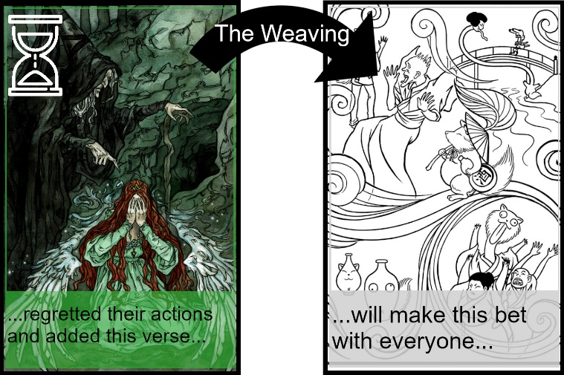
Once they’ve completed reading their Beginning card or the current Story card the Story-Teller should start telling a tale of their choosing, they can say anything, but need to remember they have to start reading aloud the text of their next card before the timer runs out, and it will need to make sense with whatever came before it. The words spoken between cards so that they all make sense together are the Weaving. Players only have as long as the Timer runs to create a Weaving that will connect the Story cards together, to Weave them into the Story.
For example, a player places the Story cards ‘…regretted their actions and added this verse…’ and ‘…will make this bet with everyone…’. Read one after another, that doesn’t make any sense at all. What the player says so that it does make sense, between the cards while the Timer is running, is the Weaving.
Motifs –
After a Story card has been read once during a Telling it becomes a Motif, a recurring theme. To represent this, all Story cards to the left of the Timer must be read out again before the Timer is moved to a new Story card. Players may like to slide Story cards slightly up or down in the line as they are read out again to keep track of what has and hasn’t been repeated. If the Timer is moved before all Motifs have been repeated for the current Story card, the Story-Teller has failed.
Telling –
- The Story-Teller reads aloud their Beginning card and then their Story cards.
  - When the Beginning card is read aloud, and before it is finished, the Timer must be flipped and placed next to it.
- The Story-Teller must move the Timer after a new Story card has started being read, before it is finished, onto that new Story card.
  - Only the Story-Teller may touch or move the Timer.
  - The Story-Teller may flip the Timer when it is moved or not, as they choose.
  - The Story-Teller may flip the Timer once each time they agree to Share The Telling.
  - Otherwise the Timer cannot be flipped or moved
- The Story-Teller may speak between each Story card, making a Weaving.
  - Each previous Story card must be read during each section of Weaving.

Sharing –
The Story-Teller may find it impossible to create a section of the weaving that includes all Motifs and fits into a single turn of the Timer. If so they may gain additional time by Sharing The Telling with their Listeners.
While the Story-Teller is telling their tale Listeners may drop Envoys next to the Story card that the Timer is currently on. The Story-Teller may flip the Timer in return for picking up an Envoy which is next to the current Story card and moving it onto the card. If they do so, once they flip the Timer they must hand over the Telling to the Listener whose Envoy they chose. The Listener continues the Telling until the Story-Teller next touches the Timer, either to move it to the next new Story card, or to flip it by adding another Envoy to the card. The Story-Teller may add multiple Envoys to a Story card in this way, and may add multiple Envoys from the same Listener, but they may not use their own Envoys. When Sharing The Telling, whoever is speaking should stop when the Story-Teller’s hand touches the Timer.
Envoys on cards will gain points during the scoring of a tale, this means that by Sharing The Telling a Story-Teller can gain extra time to repeat Motifs and Weave a story that makes sense in return for other players gaining points. It is in the best interests of Listeners to help the Story-Teller during Sharing, since if they do not they will be unlikely to be called on again and they will not gain a score.
Sharing the Telling requires a degree of co-operation of the players involved. It is entirely reasonable and in the spirit of the game for a Listener to signal with gestures their desire for the Story-Teller to move the Timer during a Sharing, or not.
Sharing is a chance to collaborate on a tale, raising the score of Story-Teller and Listener equally if used well, meaning Story-Teller and Listener gain an advantage over any other players while maintaining their relative positions.
Sharing The Tale –
- Listeners may drop Envoys next to Story cards.
- The Story-Teller may move an Envoy next to the current Story card onto it and flip the Timer.
  - If they do the Listener the Envoy belongs to takes over the Telling until the Timer is next flipped.

Failing the Telling –
There are rules to telling tales, if one of the following takes place during a Tale the Telling has failed.
- The Timer runs out.
- The Timer is moved to a new Story card before all Motifs are repeated.
- The Telling stops making sense.
If a Telling fails, immediately end Telling and go to Scoring.
Making Sense -
In Song of Tales something should only be said to stop making sense if it directly contradicts or does not follow in normal English from what preceded it, not because it is fantastical or unusual. This is a rule to encourage creation, not stifle it. It exists so that players have to create frameworks to set their Story cards in, rather than just reading them out back to back, and so that when the Timer is running low, they cannot just blurt out a series of Motifs and then move onto the next card. It should never be a matter of opinion whether something could make sense based on a flight of fancy or imagination, this rule is only breached if a player is forced to degenerate into actual gibberish in order to avoid breaking other rules.
If a Story-Teller wishes some strange and imaginative explanation for an unusual event to explain what they say it is up to them to find space to fit it into their story within the time allowed. Any flight of fancy or imagination is allowed, but they must be made within the space of the Weaving. If ever in doubt, allow the Tale to continue.
For example, if a player were running out of time and had to include the phrase ‘four sailed wooden ship’ and they say something like “…then they were amazed to see, out the window of the tower, the four sailed wooden ship, now carried aloft by a team of a thousand pegasi…”, that is considered to make sense. If they panic and instead say something like “…they were in the tower, there was a four sailed wooden ship, then they went to the top of the tower…” that can be said not to make sense, they might later claim that the ship was shrunken to the size of a toy to defend themselves, but if it was not related in the Telling then it cannot be assumed.
Ending the Telling –
A Telling can end in one of two ways:
- The Telling fails.
- The Timer is moved to the Ending card, in which case, reading. Congratulations, you completed a tale!
In either case, this tale is completed, it’s time to see how well it was told by Scoring it.
Ending the Telling –
The Telling step ends when
- The Timer is moved to an Ending card and it is read.
- A Teller or Listener fails if
  - The Timer runs out.
  - They stop making sense.
  - The Timer is moved before all Motifs have been repeated.
When the Telling ends, move to Scoring.

For example, a player taking the part of Bake Danuki plays two cards between their Beginning and Ending during Preparation, one of their colour and one not. Once they’re ready they start reading their Beginning card, “It is a common saying that…” before they finish they move the Timer onto their Beginning card (1).
Then they start telling a story so that they can read out their next card “…transformed into…” while still making sense. They might say then “It is a common saying that creatures can change their shape to get up to mischief, in fact, I know a story about a Tanuki that…transformed into…” then they can read out the card and what they say will make sense, so they start reading it out as they move the Timer across, flipping it if they want (2).
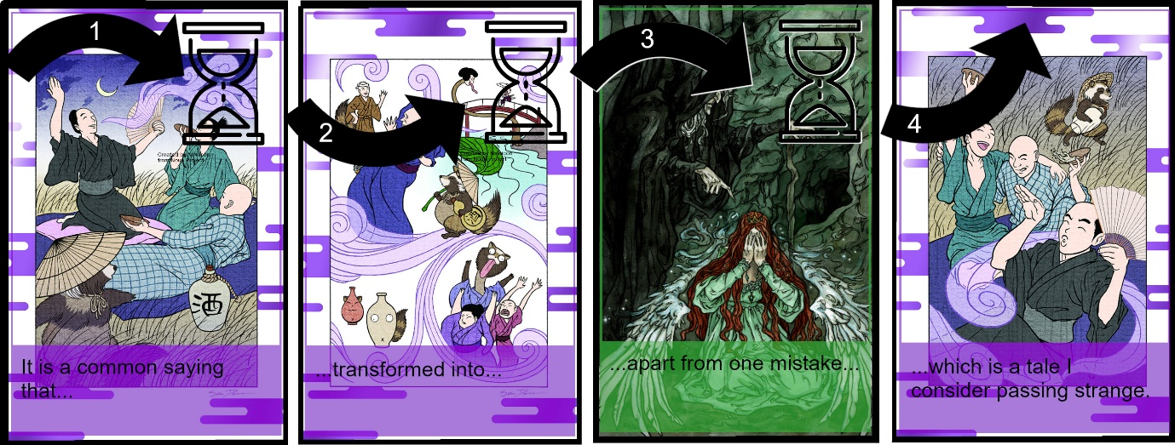
They carry on so that the new card “…apart from one mistake…” will make sense. So, they might say “…about a Tanuki that transformed into a tea-kettle, and it looked just right, the spout was right, the lid was right, the body was right, everything was right…apart from one mistake…” now they are ready to read out the new card, so they move the timer again, flipping it if they want (3).
They’re almost ready to move the timer to the Ending card and scoring their tale, but they have to read out all Story cards to the left of the current card, the Motifs, before moving the Timer again. That means they have to fit “…transformed into…” into the story again, so they carry on talking. They might say “…everything was right, apart from one mistake, the handle of the tea kettle was still as furry as a Tanuki’s tail! So, the housewife whose tea kettle it was pretending to be stoked up the fire extra hot and put the kettle right on it. Right away the Tanuki jumped up and transformed into the creature that it always was. It ran out the door with its bottom burning and the housewife laughed to see it go,” they’ve read out all their motifs, and are ready to finish their tale, so they move the timer to the Ending card and read it out, “…which is a tale I consider passing strange.” (4). Indeed it is! And it successfully completes a tale, ready to score.
If this had been part of a longer tale the teller might well have found that they were going to run out of time to fit the Motif into their weaving, maybe there would be several Motifs to fit into one section. In that case, they could call for Sinbad the Sailor to help, but moving their Envoy onto the Story card so that Sinbad can find a way to fit the Motif into the story instead, with an extra turn of the Timer.
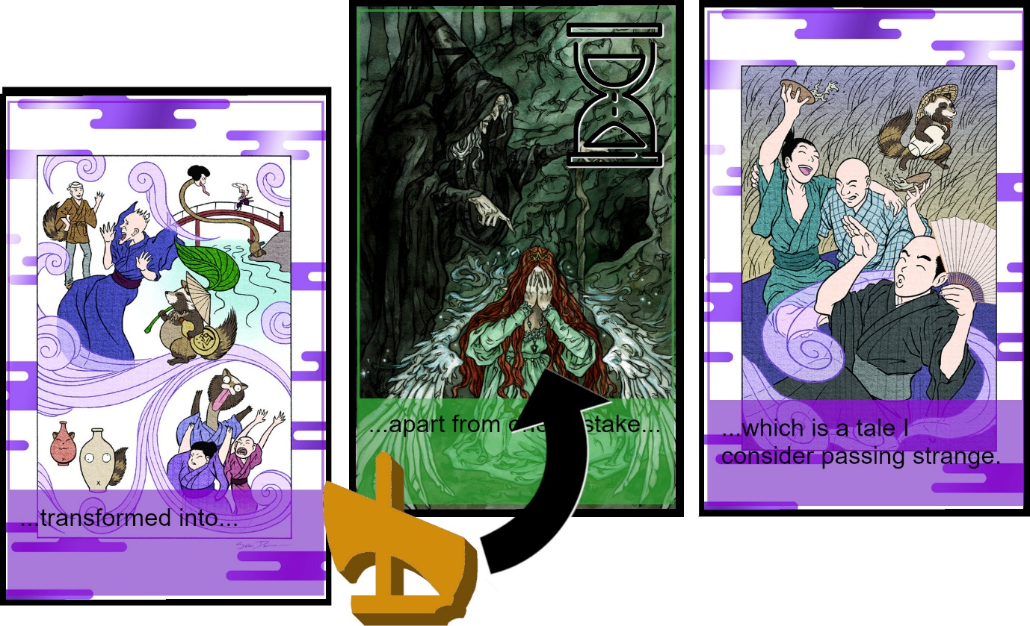
Scoring –
Scoring consists of two steps, removing failures and scoring.
To Remove Failures, discard the Story card the Timer was on when the Telling failed and all following Story cards.
Remove Failures –
- Discard the card failed during and all Story cards following them.
To Score the current tale total up the following items for players:
Scoring the Tale –
The Story-Teller scores:
- 1 point if they reached their Ending card.
- 1 point for each Story card in play
- 1 point for each Story card in play of their colour.
  - If this scores as many points as they have Envoys, 5 additional points.
Both the Story-Teller and Listeners also score
- 1 point for each of their Envoys on a card (Character or Story).
Note: Envoys are only placed on Character cards when using the rules for Character powers, which we suggest you leave out for your first game.
Note: Beginning and Ending cards are NOT Story cards, and do not score points.
To record scores, move the player’s small Envoy around the scoring track one space per point, it counts ones. Whenever it reaches the 0, move the large Envoy 1 space, it counts tens.

Resetting –
Before the next Story-Teller can take their go, there are three steps, Drawing, Cleaning and Passing.
Drawing –
The Story-Teller draws 1 Story card for each Story card still in play, plus 1. They may draw from the Story Draw Deck or from the Story cards still in play of their colour (reclaiming cards they just used). This lets a successful Story-Teller build up more cards of their own colour.
Cleaning –
Discard all Story cards still in play. Return all Envoys to their players.
Passing –
Pass the Story-Teller’s marker left, the player holding it becomes the Story-Teller and starts a new turn.
Resetting –
- Story-Teller draws “number of Story cards in play” + 1 cards.
  - May draw from Story Draw Deck or Story cards in play.
- Discard cards in play, return Envoys to players.
- Pass the Story-Teller marker left, the player holding it is the new Story-Teller.
- Start a new turn with Preparing.

Ending the Game –
The game can end in one of two ways:
The night is over – If the Story Draw Deck is empty after the Drawing step continue playing until the player holding the Last Word marker completes their turn (which may be immediately) then end the game.
The Song is Sung – If a player completes a tale where they score as many points for Story cards of their Character’s colour as they have Envoys, the Song of Tales has been sung. Passing left from the player whose turn it is until the player holding the Last Word marker, each other player has a chance to take a turn in which they must either also tell a Tale with as many Story cards of their colour as they have Envoys or pass, then the game ends.
In either case, the player with the highest score on the scoring track is the winner, the master Story-Teller and weaver of tales, the dreamer of dreams and singer of songs. Until next time friends and lovers gather about a crackling fire on a cold long night or a bottle of wine on a fine summer’s eve.
Until next time you sing the Song of Tales.
Ending –
- When the Game ends the player with the highest score on the track wins. The game ends when:
  - The Story Draw Deck runs out, carry on until the player holding the Last Word marker finishes their turn then end the game.
  - A player completes a tale with as many cards of their colour as they have Envoys, everyone to the player holding the Last Word marker may do so also, then end the game.

Character Rules –
Those are the basic rules for playing Song of Tales, once comfortable with telling stories under time pressure and managing other player’s offers players should use the Character rules.
The side of the Character board without a * next to the Character names has additional text. These are used in three additional rules, Character Powers, Favourite Words and Goals.
Character Powers –
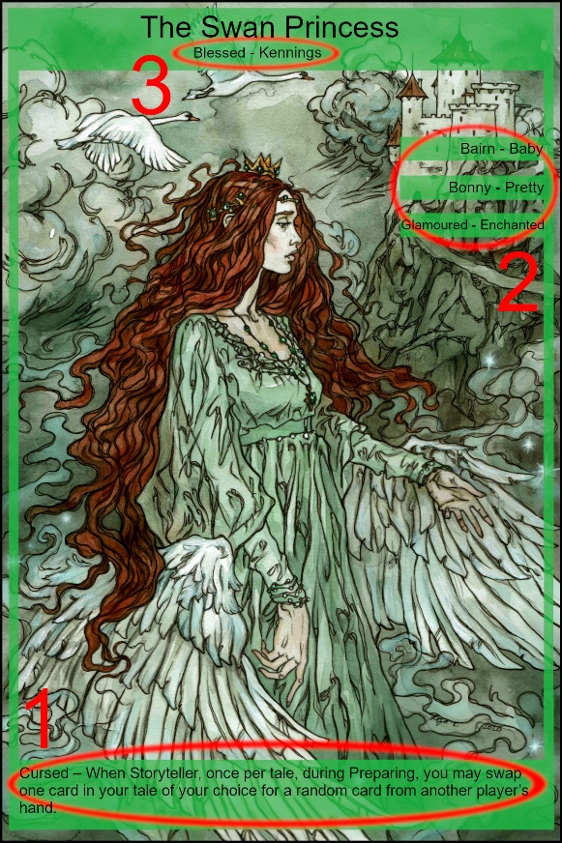
At the bottom of the cards (1) there are Character Powers which can be used to allow the Character to gain an advantage suitable to the background of their tales. Simply use them as described. Here are some explanations of how the more complicated ones work:
Ti Bouki – Born Loser – If Ti Bouki scores points from a tale but scores fewer than all other players that scored from the tale, they score an additional point. They do not score the point if they would score zero on the tale, nor do they score if no other players score from the tale or if any score the same as them. They can score if the only players to have scored less than them score zero.
The Swan Princess – Cursed – When Story-Teller once per tale during Preparing, the Swan Princess can swap a card in their hand with a random card in another player’s hand. The card they give need not be random, and they do not have to use the card they receive in the current tale.
Shahrazad – Another night – When Storyteller once per tale, if the next card is Shahrazad’s Ending they may draw the next card from the Story Draw Deck and add it to the tale as the next new Story card. They cannot look at the card before they draw and place it and cannot draw and place it before the Timer is on the last non-ending story card. Once it is placed they cannot return it to the Story Draw Deck.
Favourite words –
On the right towards the top of the cards (2) there are three separate words listed, along with some synonyms. These are the Character’s favourite words, characterful words from the region or period that the character is most associated with. Whenever one of your character’s favourite words are said within a Weaving, for the first time only, in a Tale you may drop one of your Envoys onto your character card, to claim a point during Scoring, whoever said it. Make sure to use your favourite words during a Weaving, especially when Sharing the Telling.
The words listed are quite specific to the character’s place and time and might not crop up naturally, so each comes with a synonym, a word with the same meaning but in more general usage for our day and age. Players may choose to allow uses of synonyms, including any not marked on a card as a usage of a favourite word. However, since they are marked during telling it is impossible to stop and argue over a player’s choice of a word as a synonym, if there is any doubt over using synonyms players should stick to only marking the words if used exactly as written.
Goals –
Each character card lists a Goal under the Character’s name (3). These are linguistic requirements, if they are achieved at least three (?) times during a section of the Weaving the player controlling the Character the goal belongs to may drop an Envoy onto the current Story card (remember, the Beginning card is not a Story card, so a goal cannot be scored until the Timer is moved to a Story card). The Goals are:
Sibilance – Pairs of words with Repeated s, sh, ch, z, x, f and soft c sounds at their start or end such as; “Singing sword” or “Wish fish”.
Consonance – Pairs of words with repeated consonant sounds at their start or end, such as; “Thick stick” or “Power punch”.
Alliteration – Pairs of words with repeated sounds at the start of the word only such as; “Bully boy” or “The flaming fish”.
Assonance – Pairs of words with repeated vowel sounds within them such as; “Fleet Geese” or “Spider skin”.
Rhyming – Pairs of words having similar sounding final syllables such as; “Farmer’s armour” or “Tall Wall”.
4 Syllables – A word consisting of at least four syllables such as; “Identical” or “Aberration”
Kennings – A new compound word rather than existing words such as; “The wave-floater Titanic” rather than ship or “Face-licker Fido” rather than dog.
Onomatopia – A words that sounds like the thing it is describing such as; “The Boom Box” or “The Bells of Jingling.”
Cooperative and Solo play –
When playing with one or two players you will need to use the following rules, but they may be used at higher player counts to play Song of Tales fully co-operatively.
Note: Even when playing solo, players should still tell their tales aloud.
Cooperative Sharing –
Instead of using the standard rules for sharing, in order to Share The Telling the Story-Teller hands an Envoy to the Listener they wish to take over the tale, that Envoy cannot be used to score points this turn.
Cooperative Cleaning –
During the Cleaning step the Story-Teller removes one of their Envoys from the game.
Cooperative Ending –
In addition to the standard rules for Ending the game it can end in a third way:
The Night is Short – If there are no envoys left in the game, end it immediately.
Cooperative Scoring –
At the end of the game, add all player’s scores together and then divide them by the number of players, check the result on the following table to rate your efforts:
Score
70+ You Win and are ready to take your place among the true masters.
53-69 You Win, this was an Epic tale worthy of the greats.
35-52 You Win, your tales are fine, but greatness eludes you.
18-34 You Lose, at best you are a family fireside story teller.
0-17 You Lose, you are scarcely an anecdotalist.

The Characters and their Tales –
The Characters and Story cards of Song of Tales are drawn from folk tales the world over, there are multiple resources available for those who would wish to look into any of these beautiful and fascinating stories. We have chosen a small cross section of tales from a limited number of cultures and there are many more, our choice to include one over another is based on the arbitrary requirements of game design, rather than as any sort of value judgement. We have broken down tales into recognisable moments and arranged them for game balance rather than any other reason. Rest assured that we hope there will be expansions, and many more songs to be sung of tales to be told. These are the details of the story sources used in this Song of Tales:
Europe:
Our European tales are based primarily on the Grimm’s fairytales, originally recorded in 1812 as Kinder- und Hausmärchen, gesammelt durch die Brüder Grimm. Originally intended as an academic work seeking to record and recognize the repeated motifs of folktales, many of its tales were recorded in dialect, particularly Scots, which we have recognized in the favourite words for these tales. These stories centre on curses, chants and spells tricking the pure of heart and luring them to the darkened parts of the woods.
Our Swan Princess comes from tales such as The Six Swans, from Grimm’s fairytales, The Wild Swans, by Hans Christian Andersen and the traditional Irish tale The Children of Lir, though she represents all the maidens transformed by curses and rescued by her own wits. The Wolf Stranger is the classic threat in the dark places of the world such as in Little Redcape, from Grimm’s fairytales, but they are all the threats that are given as reason not to stray from the path that arise over and again in these tales, the lure of the forbidden and the deadly fate that it promises.
Japan:
Our Japanese tales use a wide range of sources with A. B. Mitford’s Tales of Old Japan (1876) as our starting point. This volume seeks not only to translate these tales, but to place them in a context of time and place, as we have also in our own way. These tales often refer to matters of honour and debt, transformation, tricks and challenges.
According to Japanese Yokai folklore (supernatural folklore) all foxes have the power to change form, it is the tales of these transforming foxes that our Kitsune come from, such as The Grateful Foxes and The Fox Maiden. These long-lived spirits are seen as wise, often faithful and loyal guards and even wives. Conversely the Bake-danuki are the Yokai equivalent of the Japanese Tanuki, a species of racoon dog, seen as figures of good fortune they are also mischievous and sometimes foolish. The Bake-danuki is far more likely to use its power of transformation to trick, frighten and bedevil its victims for its own amusement than for any other reason.
Arabia:
Our primary Arabian influence was the Tales from the Thousand and One Nights (Trans. N.J.Darwood, 1973). Originally recorded around the end of the 18th Century in Egypt, the Thousand and One Nights are a collection of folk tales from Indian, Persian and Arab culture. Until their recording and standardisation the tales were the province of the Arab rawis, professional storytellers, who would embellish their tellings with local details or personal references, much as players of our game should seek to do. These tales are often concerned with adventures in far off places and overcoming an unpredictable and unkind world by cunning and luck.
Shahrazad is the princess who narrates the entirety of the tales in the Thousand and One Nights, and by her wisdom and eloquence saves both herself and her sister, the truest example of the power of tales to save. Sinbad the Sailor is in a tradition of characters defined by their adventures and the tides of fate, featured in his own cycle of stories, Sinbad the Sailor and Sinbad the Porter. Sinbad is tenacious and cunning, but often survives and prospers through luck alone, suggesting the higher powers of destiny and fate in our lives.
Africa:
We have used as the main source of our African tales R. S. Rattray’s translations of Akan-Ashanti Folktales (1930). Not only do these tales vary across places and peoples within the African continent but also with the spread of the African diaspora, showing the resilience of such tales, and their importance in times of hardship and struggle. Each tale is always a thread back home.
Highest in the pantheon of the Song of Tales must be Anansi, the trickster god of stories themselves, sometimes taking the form of a spider, sometimes a man, he is featured in tales such as Anansi and the box of stories. Anansi is always able to turn the tables on often more powerful oppressors by use of cunning and trickery, a theme of great importance to those that carried his stories with them to the new world. Just as a trickster can gain advantage by wit and cunning, they can often fall due to their own hubris and greed, and Ti Bouki takes the part of the eternal victim in stories such as Uncle Bouki Gets Whee-ai. Hardworking but greedy, Ti Bouki often falls foul of tricks thanks to his own greed, reminding us that stories are often just as important as lessons on what not to do.
Credits
Game Design – Glenn Ford
Illustrations – Liga Klavina, Sean Donnan, Dawn Williams, Obaseun Ogunkeye
Graphic Design – Bluepepper
Communications – Jennifer Ford
Manufacturing – LongPack Games
Playtesting – Bruno Gaia, Michael Burgess, Ray S, Jay Klitz,

